Allah
HW2

VLSI Systems Design

EE586

Students:

Mohammad Ali Mokri

Mohammad Chahardori

Due 10th October

(1). Assume that the inputs to an N-input XOR gate are uncorrelated and uniformly distributed; derive the expression for the switching activity factor.

Solution (1).
The switching activity factor of a gate is a function of output transition probability of that gate when the output change from 0 to 1 or from 1 to 0. For the calculation of the power consumption only the switching activity from 0 to 1 at the output is important, though.
The switching activity factor of an N-input gate from 0 to 1 is calculated from:
Whereis number of input bits andis the number of input bit conditions which results in output = 0 in the truth table of that gate. For a 2-bit and 3-bit XOR the truth tables are as follow:

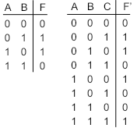
Based on the truth tables it seems that for uncorrelated and uniformly distributed inputs the probability of generating 0 at the output is and also the probability of generating 1 at the output is regardless of the number of input. As a result, the value of for an N-input XOR gate is:
Also we can easily calculate the in a same way as:
If we define the switching activity factor of the N-input XOR as the probability of seeing any change from 0 to 1 or from 1 to 0 at the output which is equal to the summation of and so we have:
(2). Consider the following circuit:
(a) What is the output voltage if only one input is high? If all four inputs are high?
(b) Compare your analytically obtained results to a SPICE/Cadence Spectre simulation.
Solution (2.a)
a.1) - This structure is a pseudo NMOS NOR gate. When only one of the input is high the output is low. That is because the NMOS transistor which is in ON goes to linear region and act as a resistor while the PMOS transistor is most likely in saturation region and act as a current source. The voltage value at the output in this condition is a function of the ratio between PMOS transistor driving capability and the driving capability of the NMOS transistor which is ON. That is, the V_{OL} value in this case is proportional to
.
To calculate the value of V_{OL} with good approximation we can use the following equation:
In this equation if we assume and we can simplify the equation as:
Where we have assumed that the V_{DD} =1.2 V.
a.2) - If in the circuit above all the input are high, in that case the whole NMOS network acts as an NMOS with
Using the above equation and considering the equivalent gives us the new value of VOL as:
As we expected, we see here the VOL when all NMOS transistors are ON is 1/4 of VOL when only one NMOS is ON, that is because the ratio of NMOS to PMOS transistors in these two case has changed by 4 times.

Solution (2.b)
In the figure bellow the schematic of the above circuit is seen which has been drawn using cadence software.
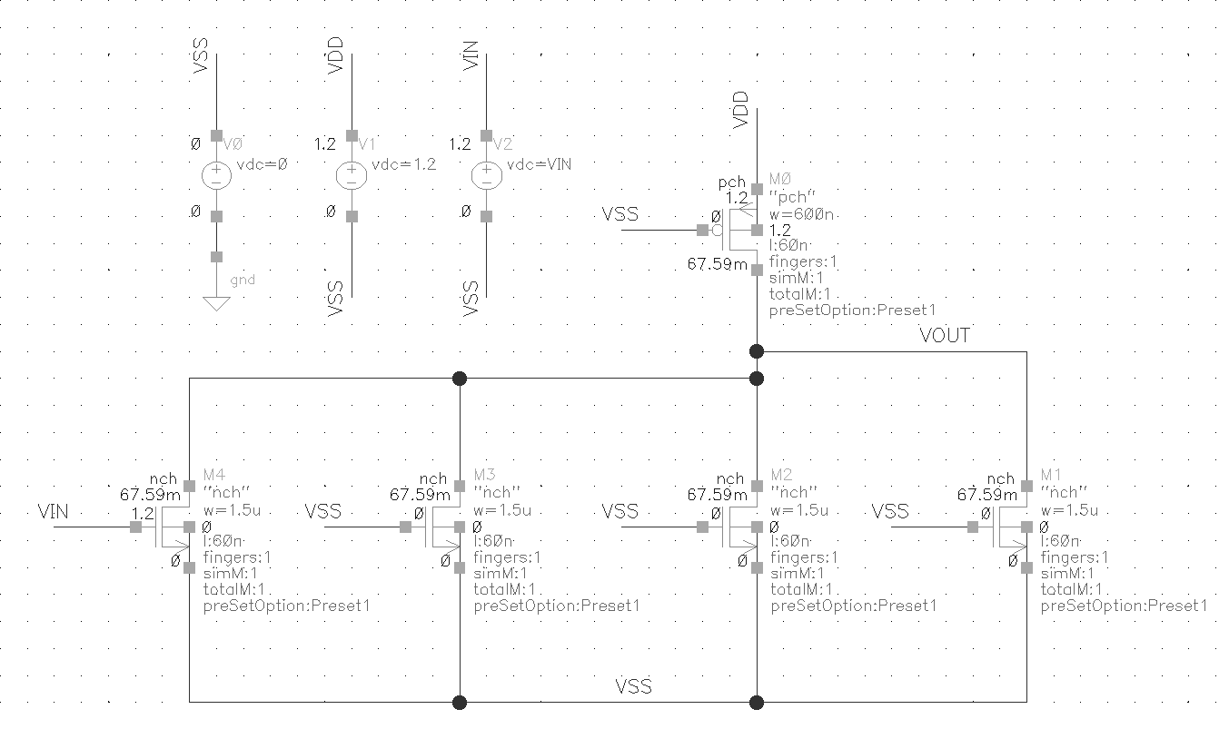
To show the VOL in the two mentioned cases, we have done two DC analysis in which the Vout/VIN curves of the gate when the gate voltage of only one NMOS (VIN in the figure) changes from 0 to VDD and all other NMOS gates are connected to ground (VSS) and also when the gate voltage of all NMOS connected together and changes from 0 to VDD are shown in the following figures.
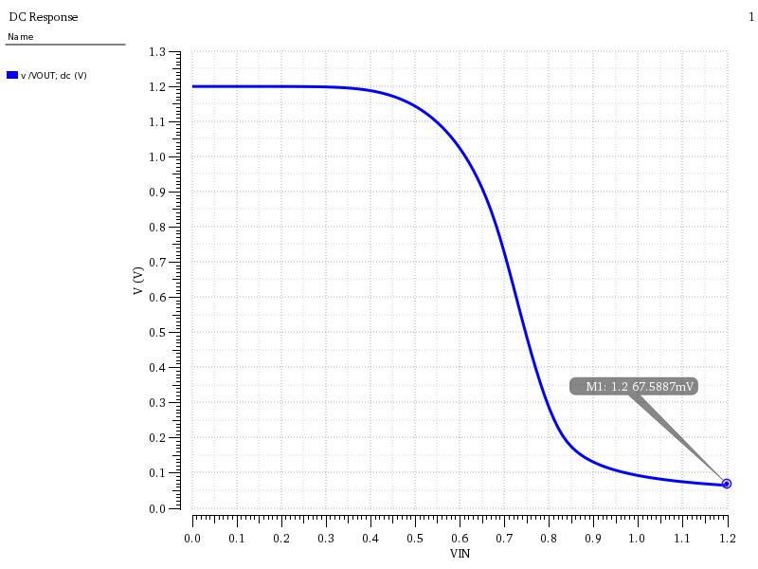
The Vout/VIN curve of the gate when only 1 input changes from 0 to VDD
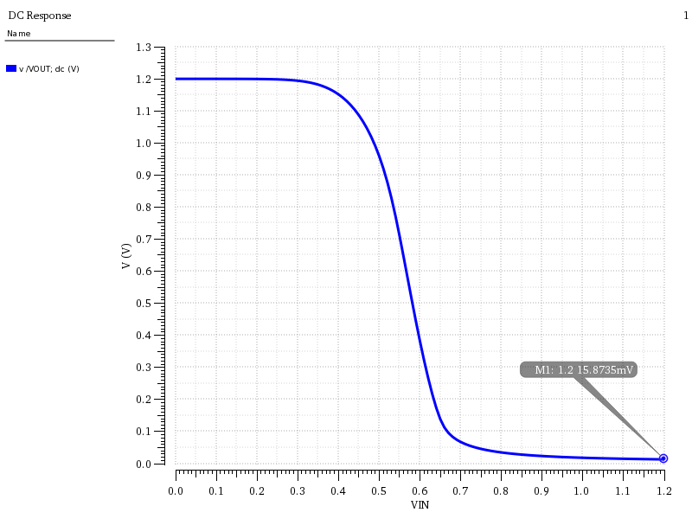
The Vout/VIN curve of the gate when all inputs together change from 0 to VDD

As we can see here when just 1 input is high the VOL is around 67mV and when all inputs are high the VOL is 15.87mV which is really close to the calculated values for VOL in these two conditions. Also as we expect the VOL in second curve is 1/4 of the VOL in first curve which is really compatible with the calculation and our expectation about the VOL ratio in two cases.

3) Consider the following pass transistor logic circuit discussed in class:
First determine the voltage at nodes X and Out when the input is logic “1”. After this step, please design the level restorer circuit. Show the voltage level at the node X when input is logic “1’ with the restorer. Size the restorer suitably so that you can reliably transmit logic “0”. You need to do this using Cadence simulation, no hand calculation will be accepted.

Solution 3.
First we need to determine the voltage at node X. because at the steady state the current through pass transistor is zero we have.
$$I_{d}\left(pass\right)=0=k_{n}\left[{(V}_{gs}-V_{tn}\right)V_{ds}-\frac{1}{2}V_{ds}^{2}]=k_{n}\left[{(V}_{g}-V_{x}-V_{tn}\right)(V_{g}-V_{x})-\frac{1}{2}{\left(V_{g}-V_{x}\right)}^{2}]$$
$$V_{x}=V_{g}-V_{tn}=V_{dd}-V_{tn}$$
As we can see there is a voltage drop equal to threshold voltage of the pass transistor.
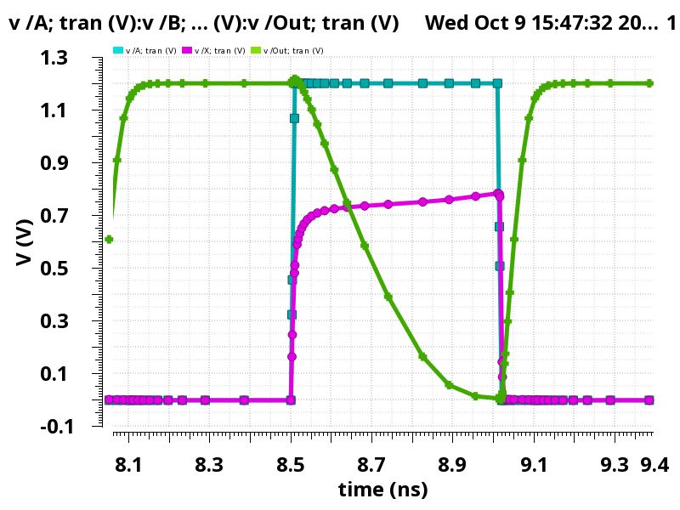
As we can see the voltage at node X is a threshold voltage less than the input voltage.
In order to restore the voltage restorer at node X we can add a restorer at node X. the circuit would become like the figure below.
Transistor sizes are given except the restorer. Based on the graphs in the lecture notes we may choose a small size PMOS for the restorer. In order to avoid low logic problem at node X we cannot pick a large PMOS for the restorer. As we can see in the graph goes to vdd for a high input and it goes to zero for a low input voltage.
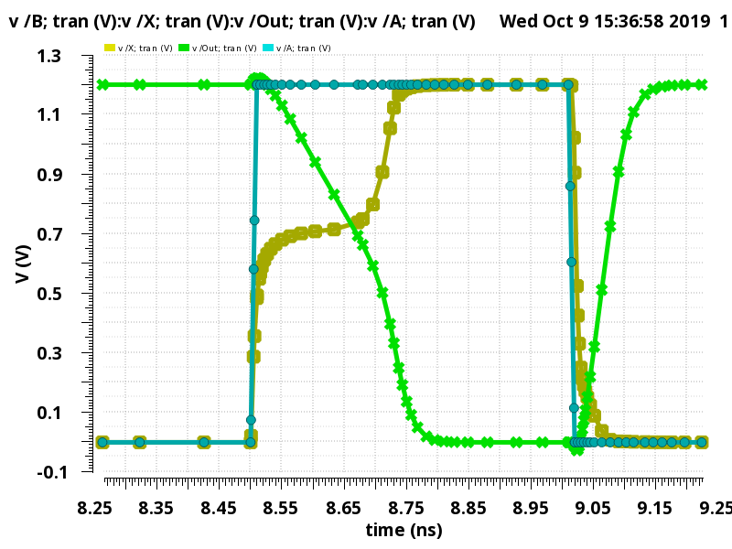
4) Now, convert the above circuit to a transmission gate logic. Demonstrate that you have full swing at node X.

Solution 4.
In this part we use a transmission gate instead of NMOS pass transistor. We use the same size for the NMOS and 2X size for the PMOS in the transmission gate.
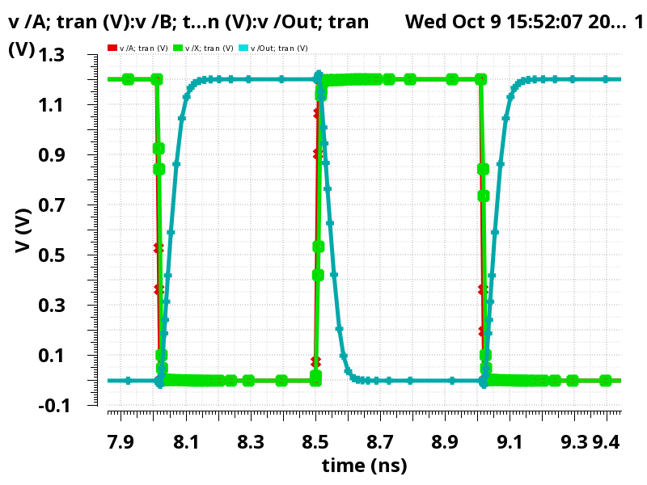
As we can see using TGate node X has a full swing without any problem.

